Credit Card Fraud Detection using Machine Learning Algorithms

# Kalvakota Rohith1, Suyash Gadiwan2

*1Kalvakota Rohith, (Mukesh Patel School of Technology, Engineering and Management)*

*2Suyash Gadiwan, (Mukesh Patel School of Technology, Engineering and Management)*

---------------------------------------------------------------------***----------------------------------------------------------------------

**Abstract –** *It is fundamental that Mastercard associations can recognize counterfeit Visa trades so customers are not charged for things that they didn't accepting. Such issues can be taken care of with Information Science and its importance, close by AI, couldn't in any way, shape or form be more critical. This errand intends to diagram the showing of an educational record using man-made intelligence with Charge card Misrepresentation Discovery. The Charge card Misrepresentation Discovery Issue joins showing past Mastercard trades with the data of the ones that wound up being coercion. This model is then used to see if another trade is tricky. Our objective here is to perceive 100% of the misleading trades while restricting the incorrect distortion game plans. Mastercard Misrepresentation Location is an ordinary illustration of request. In this connection, we have focused in on inspecting and pre-dealing with enlightening assortments similarly as the game plan of various irregularity acknowledgment computations, for instance, Local Outlier Factor and Isolation Forest estimation on the PCA changed Charge card Exchange data.*

## *Key Words*: Credit card fraud, applications of machine

## learning, data science, isolation forest algorithm, local outlier factor, automated fraud detection.

1. **INTRODUCTION**

'Extortion' in Visa exchanges is unapproved and undesirable utilization of a record by somebody other than the proprietor of that record. Fundamental counteraction measures can be taken to stop this maltreatment and the conduct of such false can be concentrated to limit it and ensure against comparable events later on. At the end of the day, Charge card. Extortion can be characterized as a situation where an individual uses another person's Mastercard for individual reasons while the proprietor and the card giving specialists are unconscious of the way that the card is being utilized. Extortion recognition includes observing the exercises of populaces of clients to appraise, see or stay away from offensive conduct, which comprise of misrepresentation, interruption, and defaulting.

This is an exceptionally important issue that requests the consideration of networks, for example, AI and information science where the answer for this issue can be robotized. This issue is especially difficult from the viewpoint of learning, as it is described by different factors, for example, class awkwardness. The quantity of substantial exchanges far dwarf false ones. Likewise, the exchange designs frequently change their factual

properties throughout the course of time.

These are not by any means the only difficulties in the execution of a genuine extortion discovery framework, in any case. In certifiable models, the gigantic stream of instalment demands is immediately examined via programmed apparatuses that figure out which exchanges to approve.

AI calculations are utilized to examine every one of the approved exchanges and report the dubious ones. These reports are researched by experts who contact the cardholders to affirm if the exchange was veritable or false. The agents give a criticism to the mechanized framework which is utilized to prepare and refresh the calculation to ultimately further develop the misrepresentation recognition execution after some time.

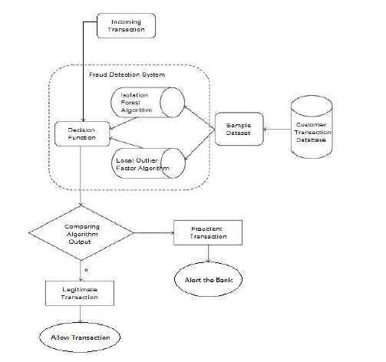

Fraud Detection methods are continuously developed to defend criminals in adapting to their fraudulent strategies. These frauds are classified as:

* Credit Card Frauds: Offline and Online
* Card Theft
* Account Bankruptcy
* Device Intrusion
* Application Fraud
* Counterfeit Card
* Telecommunication Fraud

Some of the currently used approaches to detection of such frauds are:

* Artificial Neural Network
* Fuzzy Logic
* Genetic Algorithm
* Logistic Regression
* Decision Trees
* SVMs
* KNN
* HMM
* Bayesian Networks

1. **LITERATURE REVIEW**

Misrepresentation goes about as the unlawful or criminal trickery expected to bring about monetary or individual advantage. It's anything but a purposeful demonstration that is illegal, rule or strategy with an expect to accomplish unapproved monetary advantage.

Various literary works relating to inconsistency or misrepresentation recognition in this area have been distributed as of now and are accessible for public utilization. An exhaustive study directed by Clifton Phua and his partners have uncovered those strategies utilized in this area incorporate information mining applications, robotized misrepresentation recognition, antagonistic location. In another paper, Suman, Exploration Researcher, GJUS&T at Hisar HCE introduced methods like Directed and Solo learning for charge card extortion identification. Despite the fact that these strategies and calculations got an unforeseen achievement in a few regions, they neglected to give a perpetual and predictable answer for misrepresentation discovery.

A comparable examination space was introduced by Wen-Tooth YU also, Na Wang where they utilized Anomaly mining, Exception identification mining and Distance aggregate calculations to precisely foresee deceitful exchange in a copying analysis of Visa exchange informational index of one certain business bank.

Exception mining is a field of information mining which is fundamentally utilized in financial and web fields. It manages identifying objects that are isolates from the primary framework for example the exchanges that aren't certified. They have taken properties of client's conduct and dependent on the worth of those ascribes they've determined that distance between the noticed worth of that property and its foreordained worth. Capricious methods like half breed information mining/complex organization order calculation can see illicit cases in a genuine card exchange informational index, in light of organization reproduction calculation that permits making portrayals of the deviation of one occurrence from a reference bunch have demonstrated productive commonly on medium measured online exchange.

There have likewise been endeavors to advance from a

totally new viewpoint. Endeavors have been made to work on the alert feedback communication if there should arise an occurrence of false exchange.

In the event of false exchange, the approved framework would be cautioned and a criticism would be shipped off deny the continuous exchange. Fake Hereditary Calculation, one of the methodologies that shed new light in this space, countered extortion from an alternate bearing. It demonstrated precise in discovering the fake exchanges what's more, limiting the quantity of bogus alarms. Despite the fact that, it was joined by an order issue with variable misclassification costs.

1. **METHODLOGY**

The methodology that this paper proposes, utilizes the most recent machine learning calculations to recognize bizarre exercises, called exceptions.

The rough diagram below shows the method we will use to perform credit card fraud detection:

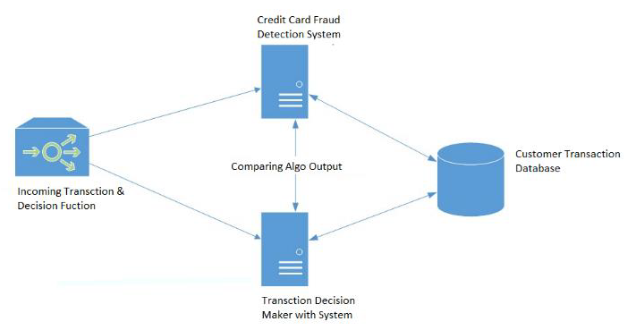

Now let’s take a look at a diagram which shows the components with real world examples, to understand what we want to do in a better way:

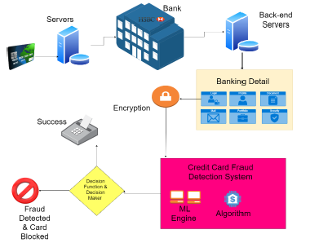

Above all else, we got our dataset from Kaggle, an information examination site which gives datasets.

Inside this dataset, there are 31 sections out of which 28 are named as v1-v28 to ensure touchy information. Different sections address Time, Sum and Class. Time shows the delay between the principal exchange and the following one. Sum is the measure of cash executed. Class 0 addresses a legitimate exchange and 1 addresses a deceitful one. We plot various charts to check for irregularities in the dataset and to outwardly fathom it:

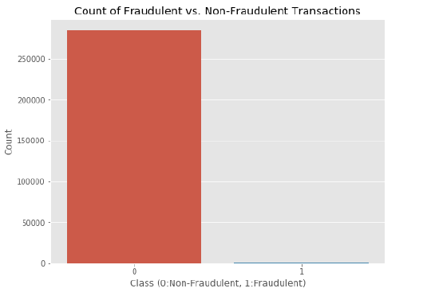

This chart shows that the quantity of deceitful exchanges is much lower than the real ones.

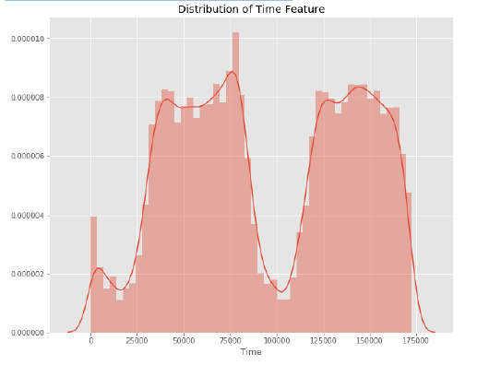

This chart shows the occasions at which exchanges were finished inside two days. It very well may be seen that the most un-number of exchanges were made during evening time and most noteworthy during the days.

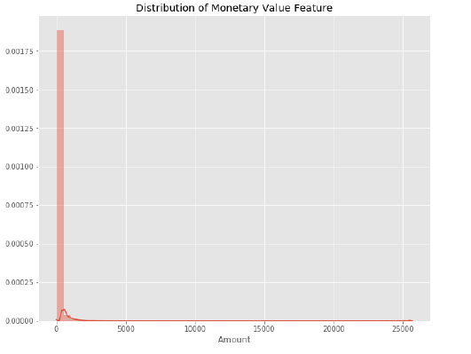

This chart addresses the sum that was executed. A larger part of exchanges is moderately little and just a modest bunch of them approach the most extreme executed sum. In the wake of checking this dataset, we plot a histogram for each section. This is done to get a graphical portrayal of the dataset which can be utilized to check that there are no absent any qualities in the dataset. This is done to guarantee that we don't require any missing worth ascription and the machine learning calculations can measure the dataset easily.

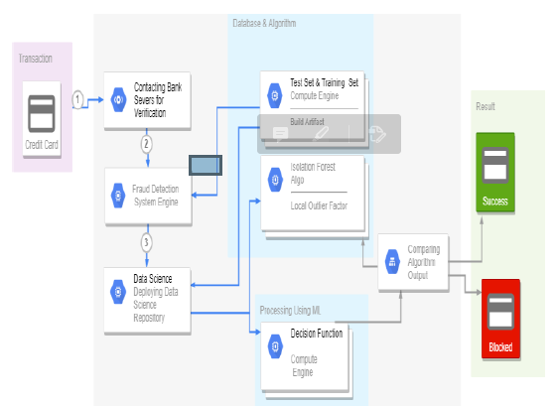

After this investigation, we plot a heatmap to get a shaded portrayal of the information and to contemplate the connection between out foreseeing factors and the class variable. This heatmap is displayed underneath:

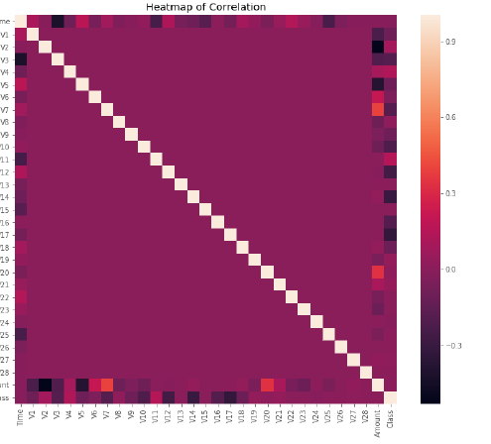

The dataset is presently organized and handled. The time and sum segment are normalized and the Class section is taken out to guarantee reasonableness of assessment. The information is prepared by a bunch of calculations from modules. The accompanying module graph clarifies how these calculations cooperate:

This information is found a way into a model and the accompanying anomaly discovery modules are applied on it:

* Local Outlier Factor
* Isolation Forest Algorithm

These calculations are a piece of sklearn. The group module in the sklearn bundle incorporates group-based techniques and capacities for the arrangement, relapse and anomaly identification. This free and open-source Python library is constructed utilizing NumPy, SciPy and matplotlib modules which gives a ton of straightforward and proficient instruments which can be utilized for information examination furthermore, AI. It highlights different grouping, grouping and relapse calculations and is intended to interoperate with the mathematical and logical libraries.

We've utilized Jupyter Note pad stage to make a program in Python to exhibit the methodology that this paper recommends. This program can likewise be executed on the cloud utilizing Google Collab stage which upholds all python note pad records. Nitty gritty clarifications about the modules with pseudocodes for their calculations and yield charts are given as follows:

A. Local Outlier Factor

It's anything but a Solo Anomaly Location calculation. 'Neighborhood Exception Factor' alludes to the oddity score of each example. It measures the nearby deviation of the example information regarding its neighbors.

All the more exactly, area is given by k-closest neighbors, whose distance is utilized to gauge the neighborhood information.

The pseudocode for this calculation is composed as:

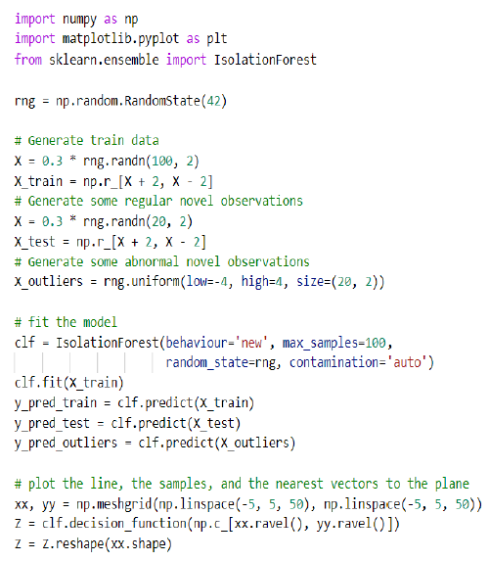

On plotting the results of Local Outlier Factor Algorithm, we get:

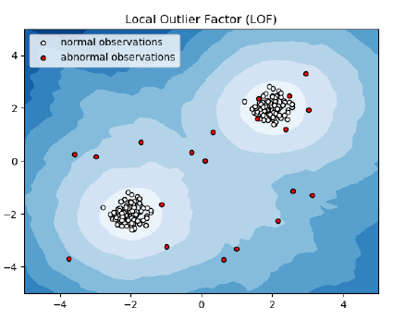

By looking at the nearby upsides of an example to that of its neighbors, one can recognize tests that are significantly lower than their neighbors. These qualities are very amanous furthermore, they are considered as exceptions.

As the dataset is enormous, we utilized just a small portion of it in out tests to diminish preparing times. The end-product with the total dataset prepared is too decided and is given in the outcomes part of this paper.

B. Forest Isolation Algorithm

The Isolation Forest 'isolates' perceptions by self-assertively choosing an element and afterward haphazardly choosing a split worth between the greatest and least upsides of the assigned highlight. Recursive parceling can be addressed by a tree, the number of parts needed to seclude an example is comparable to the way length root hub to ending hub.

The normal of this way length gives a proportion of ordinariness furthermore, the choice capacity which we use.

The pseudocode for this calculation can be composed as:

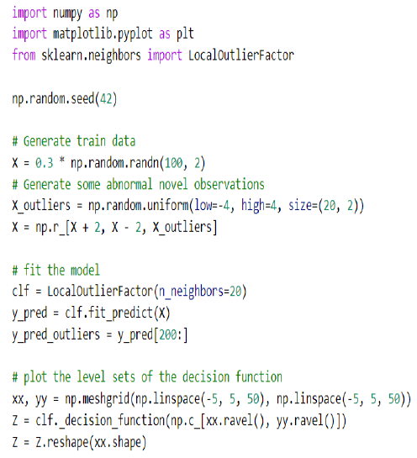

On plotting the results of Isolation forest Algorithm, we get:

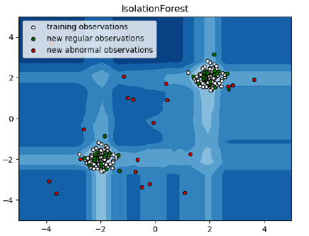

Dividing them haphazardly creates more limited ways for abnormalities. At the point when a wood of irregular trees commonly creates more limited way lengths for explicit

examples, they are incredibly liable to be abnormalities.

When the irregularities are identified, the framework can be utilized to report them to the concerned specialists. For testing purposes, we are contrasting the yields of these calculations with decide their exactness and accuracy.

1. **IMPLEMENTATION**

This thought is hard to carry out, in actuality, since it requires the collaboration from banks, which aren't able to share data because of their market contest, and furthermore because of lawful reasons and assurance of information of their clients. Along these lines, we looked into some reference papers which followed comparative methodologies and assembled results. As expressed in one of these reference papers:

"This procedure was applied to a full application informational collection provided by a German bank in 2006. For banking classification reasons, just a synopsis of the outcomes acquired is introduced underneath. In the wake of applying this procedure, the level 1 list envelops a couple of cases however with a high likelihood of being fraudsters.

All people referenced in this rundown had their cards shut to

keep away from any danger because of their high-hazard profile. The condition is more mind boggling for the other rundown. The level 2 rundown is still confined sufficiently to be minded a made to order premise. Credit and assortment officials thought about that portion of the cases in this rundown could be considered as dubious deceitful conduct. For the last rundown and the biggest, the work is evenhandedly weighty. Not exactly 33% of them are dubious. To augment the time proficiency and the overhead charges, a chance is to remember another component for the inquiry; this component can be the five first digits of the telephone numbers, the email address, and the secret key, for example, those new questions can be applied to the level 2 rundown and level 3 rundown.".

## RESULTS

The code prints out the quantity of bogus positives it recognized also, contrasts it and the real qualities. This is utilized to figure the exactness score and accuracy of the calculations. The small portion of information we utilized for quicker testing is 10% of the whole dataset. The total dataset is likewise utilized toward the end and both the outcomes are printed.

These outcomes alongside the order report for each calculation is given in the yield as follows, where class 0 implies the exchange was resolved to be legitimate and 1 method it was resolved as a misrepresentation exchange. This outcome coordinated against the class esteems to check for bogus positives.

Results when 10% of the dataset is utilized:

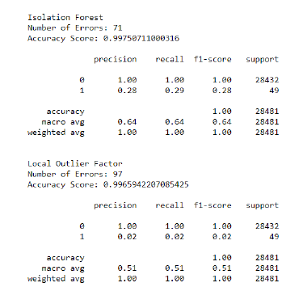

Results when the complete dataset is used:

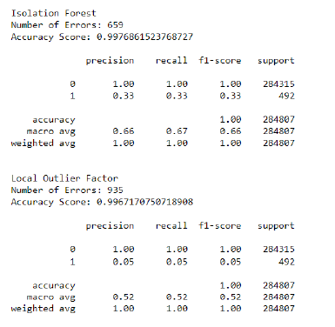

## CONCLUSION

## Mastercard misrepresentation is definitely a demonstration of criminal contemptibility. This article has rattled off the most widely recognized techniques for misrepresentation alongside their discovery strategies and checked on late discoveries in this field. This paper has moreover clarified exhaustively, how AI can be applied to improve brings about misrepresentation recognition alongside the calculation, pseudocode, clarification its execution and experimentation results.

## While the calculation comes to more than 99.6% precision, its

## accuracy stays just at 28% when a 10th of the informational collection is mulled over. In any case, when the whole dataset is taken care of into the calculation, the accuracy ascends to 33%. This high level of exactness is to be relied upon due to the enormous awkwardness between the quantity of legitimate and number of authentic exchanges.

## Since the whole dataset comprises of just two days' exchange records, just a small part of information can be made accessible on the off chance that this venture was to be utilized on a business scale. Being in light of AI calculations, the program will as it was incrementing its effectiveness over the long run as more information is placed into it.

## FUTURE ENHANCEMENTS

## While we were unable to connect objective of 100% exactness in misrepresentation recognition, we wound up making a framework that can, with sufficient opportunity and information, get exceptionally near that objective. Likewise with any such venture, there is some opportunity to get better here.

## The actual idea of this task takes into consideration different calculations to be incorporated together as modules and their outcomes can be consolidated to expand the exactness of the eventual outcome. This model can additionally be improved with the option of something else calculations into it. Notwithstanding, the yield of these calculations should be in a similar configuration as the others. When that condition is fulfilled, the modules are not difficult to add as done in the code. This gives an extraordinary level of measured quality and

## adaptability to the venture. More space for development can be found in the dataset. As exhibited previously, the accuracy of the calculations increments at the point when the size of dataset is expanded. Consequently, more information will clearly make the model more precise in distinguishing cheats and diminish the quantity of bogus positives. Nonetheless, this requires official help from the actual banks.

REFERENCES

[1] “Credit Card Fraud Detection Based on Transaction Behaviour -by John Richard D. Kho, Larry A. Vea” published by Proc. of the 2017 IEEE Region 10 Conference (TENCON), Malaysia, November 5-8, 2017

[2] CLIFTON PHUA1, VINCENT LEE1, KATE SMITH1 & ROSS

GAYLER2 “ A Comprehensive Survey of Data Mining-based Fraud Detection Research” published by School of Business Systems, Faculty of Information Technology, Monash University, Wellington Road, Clayton, Victoria 3800, Australia

[3] “Survey Paper on Credit Card Fraud Detection by Suman” , Research Scholar, GJUS&T Hisar HCE, Sonepat published by International Journal of Advanced Research in Computer Engineering & Technology (IJARCET) Volume 3 Issue 3, March 2014

[4] “Research on Credit Card Fraud Detection Model Based on Distance Sum – by Wen-Fang YU and Na Wang” published by 2009 International Joint Conference on Artificial Intelligence

[5] “Credit Card Fraud Detection through Parenclitic Network Analysis- By Massimiliano Zanin, Miguel Romance, Regino Criado, and Santiago Moral” published by Hindawi Complexity Volume 2018, Article ID 5764370, 9 pages

[6] “Credit Card Fraud Detection: A Realistic Modeling and a Novel Learning Strategy” published by IEEE TRANSACTIONS ON NEURAL NETWORKS AND LEARNING SYSTEMS, VOL. 29, NO. 8, AUGUST 2018

[7] “Credit Card Fraud Detection-by Ishu Trivedi, Monika, Mrigya, Mridushi” published by International Journal of Advanced Research in Computer and Communication Engineering Vol. 5, Issue 1, January, 2016

[8] David J.Wetson,David J.Hand,M Adams,Whitrow and Piotr Jusczak “Plastic Card Fraud